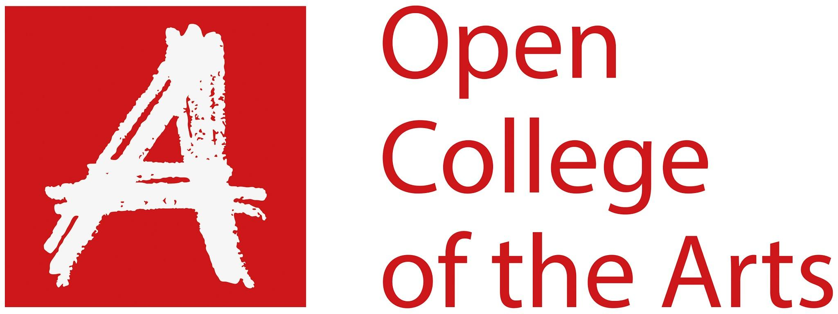

Formative feedback

Student name | Nuala Mahon | Student number | 513668
Course/Unit | Digital Image and Culture | Assignment number | 3
Type of tutorial | Written / Audio-Visual |  | A/V

Overall Comments
Many thanks for the time taken for the Skype on Friday 1st May. Below is a summary of our conversation – do let me know if I have missed anything out. I have also sent this as word document so do make comments in response – if you could put your comments in a different font or colour that is really useful

Your work was viewed on your blog at:
https://diandc.home.blog/

Feedback on assignment
Demonstration of technical and Visual Skills, Quality of Outcome, Demonstration of Creativity
The essay was submitted on your blog. We discussed the topic and structure on the draft as it is at this stage. You also had additional comments from other readers on the essay

The topic has been clearly defined and there is a readable structure to the essay.
The introduction is well written and gives a clear insight to the early days of the internet (more on this later..) However, I suggested to cut this down to free up words to use later on in the essay.

We discussed the passage of the selfie and where that should sit in the structure of the essay.

The use of the graphs and illustrations on the data held on you was interesting. There is potential for the representation of this to be used as a project.

I suggested using more illustrations in the final version for submission – as this is uploaded via the G Drive and not published on the web. It will be worth stating on your blog where the full final version is available for assessment.

This is the link to Carole Cadwalladr’s TED talk on the recent role fo Facebook in elections:
https://www.ted.com/talks/carole_cadwalladr_facebook_s_role_in_brexit_and_the_threat_to_democracy?language=en

We also discussed assignment 4/5/6 and the progression of how this project may work. You outlined several ideas and I also suggested looking at personal story from the development of the internet.

You agreed to draft a proposal and the email me when at a stage ready to start work.

Coursework
Demonstration of technical and Visual Skills, Demonstration of Creativity
On your blog you have interacted with the material in this part in detail. We discussed war photography.

Giles Duley is a photographer you may wish to follow up on – his major project is Legacy of War. On Instagram he also has another account – one_armed-chef – which is focussed around cooking meals with those he meets.

Research
Context, reflective thinking, critical thinking, analysis
This continues to be detailed and well logged. You are an avid film watcher and this is recorded on your blog. It may be that film can be starting point/reference for assignment 4.

Learning Log
Context, reflective thinking, critical thinking, analysis
The blog continues to develop through the assignment diaries and it is good to read the developments on Assignment 2.

You are active on using other readers and students to think about your work – do continue to do this.

Suggested reading/viewing
Context
I’m never sure which students you may have come across on forums/hangouts.

Sarah-Jane has just completed DI&C and her final piece uses both appropriated sound and vision:
https://sjfdiculture.wordpress.com/

Pointers for the next assignment / assessment

Please inform me of how you would like your feedback for the next assignment: written or video/audio.

Strengths | Areas for development
Essay has clear structure and premise | Shorten introduction and work on second draft to refine arguments/ideas further
Good engagement with issues presented in coursework. | Continue to develop your work in this vein.
Ideas of for assignment 4 | Exploring your proposals for a direction to go in.

Tutor name | Andrea Norrington
Date | 5th May 2019
Next assignment due | 30th June 2019

